|  |
| --- |
| Software Requirements Specification for |
| Delicious – Online Restaurant Food Ordering Process |
| Version 1.0 approved |

|  |
| --- |
| Prepared by  Md Rijwan Razzaq Matin | SCM-024522  Avinesh Pillay Selvaraj | SCM-031268  Ahson Junani | SCM-030149  < March 25, 2016 > |

Table of Contents

1. Introduction 2

1.1 Purpose 2

1.2 Project Scope 3

1.3 Glossary 4

1.4 References 6

1.5 Document Overview 6

2. Overall Description 9

2.1 System Environment 9

2.2 Functional Requirements Definition 10

2.3 Non-functional Requirements 11

2.4 Assumptions and Dependencies 11

3. Overall Description 12

3.1 External Interface Requirements 12

3.2 Functional Requirement 13

3.3 Detailed Non-functional Requirements 14

Safety 14

Security 15

Human engineering 15

Performance 15

4. Other Requirements 16

5. System Evolution 17

Table of Figures

Figure 1: Software for System Environment…………………………………………………………………………………………………….9

Figure 2: Use Case Diagram for Functional Requirement…………………………….…………………………………………………10

Figure 3: Sample of screen images and GUI components of website……………..………………………………………………13

# 1. Introduction

## 1.1 Purpose

The product accomplished and delivered from this document that specifies software requirement would be a dynamic web application. It will also provide the directions towards building a healthy lifestyle among customers that choose Delicious for the meal that they wish to order. Besides that, it will also promote a good relationship between the customers and the staff of Delicious by allowing them to be informed with the company’s objectives and goals. Other than that, Delicious will be able to make more profit by outreaching many people who will make orders from every part of the country as long they have an internet connection. This dynamic web application will be compatible with personal computer provided they have a web browser. There are some major functions that will be performed in this web application. One of the functions of this web application is that it provides customers support by enabling them to submit their enquiries to staffs of Delicious. The other function that will be provided by this web application is that it educate the customers of Delicious in consuming healthy meal and promoting health awareness via informing the customers about the contents of the nutrients in the meal that they wishes to order. It also allows direct sales by allowing customers to order directly the meals that they chooses to order even though they are not the member of Delicious. After customers submit their order, a receipt will be generated for the customers based on their meals that they have chosen. Customers that wishes to be a member of Delicious are allowed to log into the web application provided that they registers their personal information if this is their first time logging into the web application. Different users of the web application are given different priority in accessing the contents in this web application based on their role and responsibility and the information that needs to be accessed. Last but not the least; the dynamic web application will also be introduced to the promotions and menus that are offered by Delicious and contacts information if customers wish to contact directly with the Delicious Customer Service.

## 1.2 Project Scope

The software being specified in this document is a dynamic Web Application that allows information entered by user of this web application to be processed and the main purpose of it is to enable online food ordering. It has several benefits such as increasing the company’s total profits because more people will have access to the Delicious menu via the web application, hence more orders will result in an increase in total sells. It also has a benefit to all the users of this software where this website will have detailed information about food nutrition including how to maintain healthy living by eating healthy. This information will educate the people making online orders or just the viewers of Delicious that who access this website. The objectives of creating this web application for Delicious is to improve consumers’ awareness towards the importance of maintaining a healthy lifestyle from the meals that they choose to consume and allowing them to access food that is satisfying and is within their budget and also to reach out to everyone in all the parts of the country via the use of this web application that will be created provided they have an internet access. It is also to provide a wide range of choices for customers in choosing their meal that is healthy and meets their desires, to enable customers to effectively control their own calorie intake based on the food that they will consume, it is also to increase the revenue and profits of the Delicious restaurant by developing a web site that will attract customers via its design. Another objective is to enhance customer satisfaction by using the web application at their own comfort and convenience. Lastly, it is to develop menus that are delicious and contains more items that customers want and are willing to pay for. The goal of creating this dynamic web application is to promote health awareness to customers of Delicious by the daily meal that they choose to consume. Besides that, expanding the geographical reach regardless where the customers’ reside is also one of the goals of developing this web application project. This web application also allows in an attractive and simplest way in delivering information to customers of Delicious regarding the company objectives and menus that will be offered.

## 1.3 Glossary

Accessibility: Accessibility is the degree to which a product, device, service, or environment is available to as many people as possible. Accessibility can be viewed as the "ability to access" and benefit from some system or entity.

Adaptability: Adaptability is a feature of a system or of a process. This word has been put to use as a specialized term in different disciplines and in business operations. Word definitions of adaptability as a specialized term differ little from dictionary definitions.

Availability: Characteristic of a resource that is committable, operable, or usable upon demand to perform its designated or required function. It is the aggregate of the resource's accessibility, reliability, maintainability, serviceability, and sociability.

Correctness: To set or make true, accurate, or right; remove the errors or faults. Dinner: The main meal of the day, taken either around midday or in the evening.

Flexibility: Ability to be easily modified.

Food and Drug (FAD): The FDA is responsible for protecting and promoting public health through the regulation and supervision of food safety, tobacco products, dietary supplements, prescription and over-the-counter pharmaceutical drugs (medications), vaccines, biopharmaceuticals, blood transfusions, medical devices, electromagnetic radiation emitting devices (ERED), cosmetics, animal foods & feed and veterinary products.

Goals: An observable and measurable end result having one or more objectives to be achieved with in a more or less fixed time frame.

Graphic User Interface (GUI): It is a human-computer interface (i.e., a way for humans to interact with computers) that uses windows, icons and menus and which can be manipulated by a mouse (and often to a limited extent by a keyboard as well).

Human Resource Department (HRD): It is a critical component of employee well-being in any business, no matter how small. HR responsibilities include payroll, benefits, hiring, firing, and keeping up to date with state and federal tax laws.

Interoperability: It is the ability of a system or a product to work with other systems or products without special effort on the part of the customer.

Maintainability: Ability of a computer program to be retained in its original form, and to be restored to that form in case of a failure.

Portability: Portability is a characteristic attributed to a computer program if it can be used in operating systems other than the one in which it was created without requiring major rework.

Reliability: The ability of an apparatus, machine, or system to consistently perform its intended or required function or mission, on demand and without degradation or failure.

Reusability: It is the use of existing assets in some form within the software product development process. More than just code, assets are products and by-products of the software development life cycle and include software components, test suites, designs and documentation.

Robustness: It is the ability of a computer system to cope with errors during execution. Robustness can also be defined as the ability of an algorithm to continue operating despite abnormalities in input, calculations, etc.

Schedule: It is a plan for carrying out procedure or giving list of intended events and time.

Testability: It is an extrinsic property which results from interdependency of the software to be tested and the test goals, test methods used, and test resources.

Usability: It is the ease of use and learnability of a human-made object. The object of use can be a software application, website, book, tool, machine, process, or anything a human interacts with.

## 1.4 References

* n.d., n.d., M I’m lovin’ it’. [Online], Available at: (http://www.mcdonalds.com/us/en/home.html/) [Accessed 4 November 2014]
* Adams, J., Baker, B., and Charlie, C., 2004. Web Publishing System. n.d.
* Wiegers, K., 2002. Cafeteria Ordering System. n.d.
* Ashley Friedlein, 2001. Web Project Management. Morgan Kaufmann.
* Breandán Knowlton, 2012. Managing Web Projects. Five Simple Steps
* Thomas A. Powell, David L. Jones, Dominique C. Cutts, 1998. Web Site Engineering. Prentice Hall PTR
* Jason Whittaker, 2002. Web Production for Writers and Journalists. Psychology Press
* Daniel A. Tauber, Brenda Kienan, 2001. Managing Web Projects For Dummies. Wiley.

## 1.5 Document Overview

This document of software requirement specification constitutes five sections which are introduction, overall description, requirement specifications, other requirements and system evolution. In introduction, there are five subsections that will be discussed. One of the subsections would the purpose. In purpose, there will be information that will be discussed related to the product that will be obtained from this document, the release version of this document and the functionality that is supported by the web application that will be developed.

The other subsection is the project scope. In project scope, the benefits that will be gained from this document of software requirement specification, the objectives, goals that will tend to achieve from developing this web application and also description in how this web application that will be developed can be related to the corporate goals.

The next two subsections are the glossary and references. In glossary, there will terms that carries special meaning in this document of software requirement specification and in references there will be citing if references taken from other source for ideas in writing this document of software requirement specification.

The last section of this introduction is document overview which provides guidelines for users to understand what each section of this document is about. The next section would be overall description.

In overall description, there are four subsections. The first subsection is system environment. In system environment, there will be detailed information on platform that is required in order to run this web application. Platform that is meant are such as hardware, software and network. The next subsection is functional requirement definition. In this subsection, a use case diagram will be drawn on the features and function that will be included in the dynamic website that will be developed, the accessibility of this functions and how it relates to the users in using the function via showing the processes involved. The next subsection is the non-functional requirement. In this subsection, a brief explanation on how the web application will behave when the user enters into the web application and the security features and restriction that are included in the website in order to protect the data from being loss or deleted will be discussed. The last subsection of this section is assumption and dependencies. In this subsection, it details the requirement that need to be attained in order to use this web application or the functions in the web application and is there any software need to be installed when using the web application by the user in the client computer. Besides that, the next section of this document is requirement specification.

In this requirement specification, there are three subsections. The first subsection is external interface requirement. It describes the interfaces which may include the website layout, the button used, functions available for user in each screen of the website, shortcuts that available for user, error message that will appears and logical characteristics of the interface. The next subsection is functional requirement. In this subsection, a detailed explanation of the function that that is drawn in the use case diagram will be explained. The features of the website will also be discussed. Detailed non-functional requirement is the last subsection of this section. In this subsection, detailed information regarding the characteristics of the website and the reason for such characteristics will be explained. There is some explanation on how the security of data is kept and what type of information will be entered by the user. There is also explanation on adaptability, availability, correctness, flexibility, interoperability, maintainability, portability, reliability, reusability, robustness, testability and usability of the website and the function in the website will be discussed. Moreover, the next section is other requirements.

In this section, there will be information on other functional and non-functional requirement that need to be added if it is not mention earlier in this software requirement specification document. The last section of this software requirement specification is the system evolution. In this section, there will be discussion on the new features or new development that might be updated in future the dynamic website in order to meet the current global needs.

# 2. Overall Description

## 2.1 System Environment

This system operates under two environments which are the developer side and user side. On the user side, the software will operate on any personal computer running any Operating system such as Windows XP onwards, Ubuntu, Macintosh and Linux. This will only be possible if there is a web browser and it is connected to the internet. On the developer side, this software used to develop the web application are Xampp which makes the developers PC a client-server and Dreamweaver for designing the entire dynamic web application, a web browser is also one of the software used by the developer to test the web application during the development stage and for this purpose it will be Google Chrome. Photoshop is also software used by the developer used to design the Delicious logo and graphic editing. The hardware used in this environment includes Web Server for hosting the website and a Database server for storing the customer information.





Figure 1: Software for System Environment

## 2.2 Functional Requirements Definition

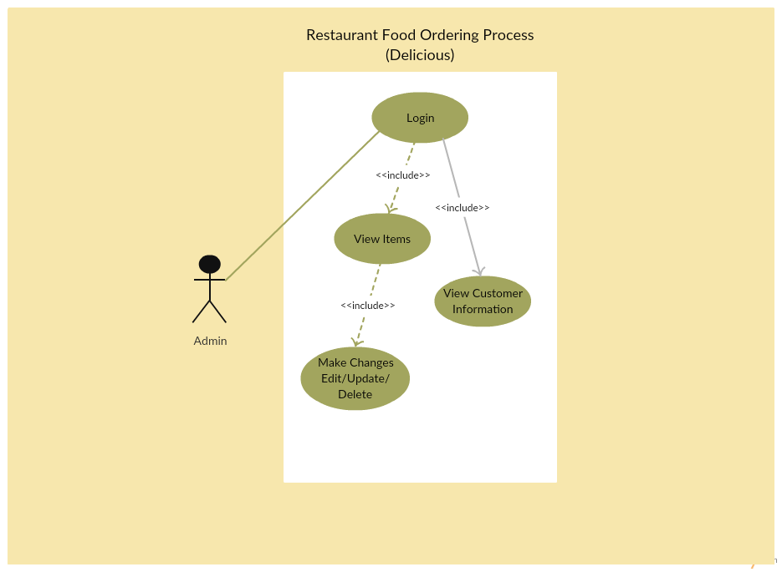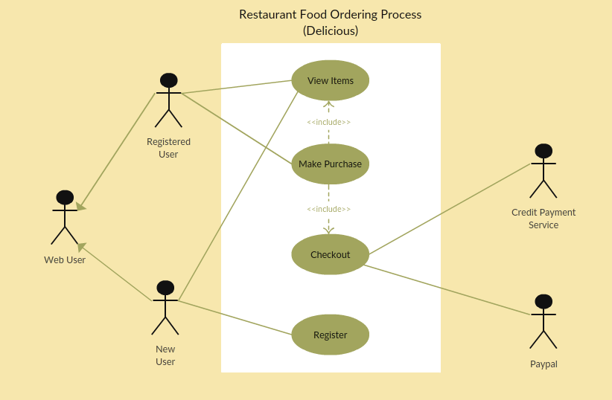

Figure 2: Use Case Diagram for Functional Requirement

## 2.3 Non-functional Requirements

The design patterns of the Delicious Online Food Ordering System are pretty much the standard for a web application; the non-functional requirements of the system are very straightforward. Although written using Dreamweaver, the application is cross-compiled to HTML and JavaScript, along with a PHP backend, all of which are supported by XAMPP. All of the application data is stored in a PostgreSQL database, and therefore a PostgreSQL server must also be installed on the host computer. The server hardware can be any computer capable of running both the web and database servers and handling the expected traffic. For a restaurant that is not expecting to see much web traffic, or possibly doing only a limited test run, an average personal computer is appropriate.

## 2.4 Assumptions and Dependencies

We are assuming that every customer will have basic knowledge to use and navigate on a website hence no tutorials will be provided. We also assumed that customers will have the knowledge concerning the “or” and “and” function when making orders for example a menu will have a choice like ‘burger and chips’ and another choice like ‘burger or chips’. We are depending on the assumption is that our targeted customers are capable of operating a computer in order to access the website. Besides that, the users who will be using this website for ordering their meal is between the ages of 16 to 65 years. In order to login or register as a member of Delicious, the customer must have e-mail address. To perform some of the function in this web application, it may depend on the adobe flash player, so that the adobe flash would be required to some extent as its dependent for the website to works in client computer. This website is also dependent on the fact that every user PC must have a web browser and they are connected to an active Internet connection.

# 3. Overall Description

## 3.1 External Interface Requirements

This dynamic web application uses the skin color of red. The reasons behind choosing red as the skin color would be it stimulates hunger. Therefore, by, every time customers use the website, it causes the chances for customer in stimulating them in ordering their meal via this website will be high. The fonts that will be used in this dynamic website would be Times New Roman. The font color that will be chosen is black, white and yellow. The reason behind using this font type is that it gives a professional look to the website. The logo of Delicious would be placed in the top left corner followed by the main function beneath it. When user point their mouse to the main function, there will sub functions emerging from there. Every time user click one of the main functions such as menu function it possess to the function’s page which remain in the same tab without being opened in the new window or new tab. Every page there will be linked to hone page when user click on the logo of the Delicious. In every page there will be the main functions displayed together with the company’s logo. Besides that there will be a message that will be shown when order has successful submitted. There will also be validation shown when user inputs their information during login or registering. The hardware component that is required is a personal computer, tablets and mobile phones. The software and communication that is required for this software is such as the e-mail, Facebook, YouTube, Twitter and Google Plus so that customers can send enquiries if they wish to, web browser in order to access this website, database to store customers’ information and protocols such as File Transfer Protocol, PostgreSQL, Simple Mail Transfer Protocol, Transmission Control Protocol and Hyper Text Transfer Protocol. The five main function that will remain in all the pages of the website when user enter each pages are such as home, menu, location, contact us and login. In the menus, there will a display on the types of food and drinks together with their price and nutrients contents. In the location, there will be a list of all the branches with maps. Besides that, in the contact us function, there will be contact information of the company including the company’s address and outlets. Lastly, the function login is to allow customers and staffs of Delicious to login into the website in order to order their meals if they are customers of Delicious and if they are staff, they are allowed to view the users information. Beneath the site, there will links that allows user to connect to social networking site of the Delicious Below shows the sample of screen images and GUI components that will be on the website.

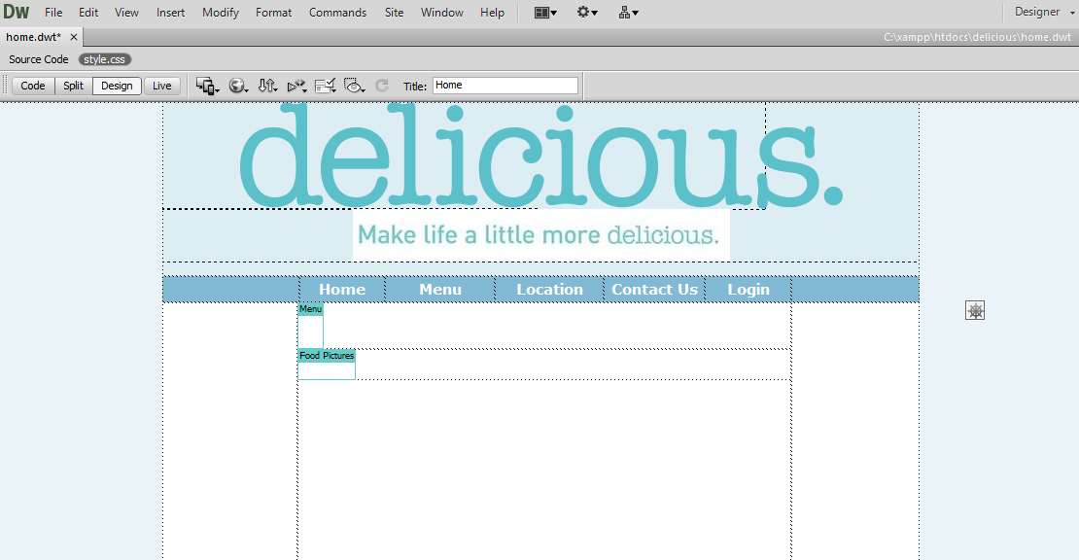

Figure 3: Sample of screen images and GUI components of website

## 3.2 Functional Requirement

When a customer visits the site or any individual visit the website, the first thing that the customer will see is the home page. When a non-registered member or customer visits, the system will allow the customer to view all the pages. But the system will not allow a non-registered member or individual to make an order. And when a non-registered member visit the site, he can click or select the signup link from the Login page and then a form will appear for him to fill in his details. After the details are filled and submitted via the submit button, given an individual information is correctly entered, the system will display on the screen, you are now a registered customer, please proceed to login to make your order.

And when a registered member visits the site, he will login his/her user name which is the email that the customer signed up with his/her password. After that has been done successfully, the system will display a form that will allow a customer to make an order. And when selecting the meal, the system will be calculating the price of the meal that are selected. Upon completion of a successful order, a receipt will be displayed on the screen containing all the details that has been entered.

The Admin has the access to login direct to the database and then view the list of order details. The list of customers order information will be arranged in a row, then the admin will select or click on a customer order and then the full order information or detail will be will be displayed on the screen. And also the Human Resources Department (HRD) also has a login information as admin that will allow them to have access to the database and view customer personal information.

## 3.3 Detailed Non-functional Requirements

This subsection presents the identified non-functional requirements for the Delicious web application. The subcategories of non-functional requirements given are safety, security, human engineering and performance.

### Safety

* The system shall log every state and state change of every surface computer, tablet and display to provision recovery from system failure.
* The system shall be capable of restoring itself to its previous state in the event of failure (e.g. a system crash or power loss).
* The system shall be able to display a menu at all times to facilitate manual order taking should the need arise.
* The system shall utilise periodic 30-second keep-alive messages between the device a user or customer is using and the server to monitor device operational status.
* The system shall flag devices that fail to send timely keep-alive messages as non-operational.

### Security

* Wireless communication throughout the system will be encrypted using SSLv3 at the application layer and WPA2-PSK at the data link layer.
* The WPA2-PSK password used for wireless communication must have a bit- strength of at least 80 bits.
* The WPA2-PSK password used for wireless communication must be changed every three months.
* The system shall provide three levels of access: A manager level for unrestricted access to system functionality, a coordinator level and a customer level.
* A user shall be required to log in using a username and password.
* A user shall not be requested to log in to view the menu, promotions and user reviews.

### Human engineering

* Any element of the system will take no longer than 10-seconds to restart.
* A surface computer must not dismiss an engaged menu unless the customer requests it.

### Performance

* The server shall be capable of supporting no less than 200 concurrent connections from any combination of surface computers, tablets or any device.
* The server shall be capable of supporting an arbitrary number of surface computers, tablets and displays, that is, it shall provide no limit on how many devices are in the system.
* The server shall be capable of supporting an arbitrary number of active meals/orders, that is, no meals/orders shall be lost under any circumstances.

# 4. Other Requirements

This dynamic web application will come with a function of database. A logical database can stretch over multiple physical hard disks and information files. The data storage unit is still a single database for information retrieval purposes. To have a logical database, all given hard disks and information files must be accessible from a single source. An example would be a personal computer able to access its information files stored on multiple hard drives from a single user interface. The requirements for a physical database vary by the parameters of the storage device in question. For example, a flash drive designed to hold up to 2 gigabytes of information or more needs a personal computer or another USB-connected device to allow access to the information stored on the equipment. A physical database also needs a power source to access information. A computer hard drive cannot function without electricity. A flash drive cannot operate without a device with an adequate power source. The legal requirement that is required in order to operate the website will be obtained from the Food and Drug Agency (FAD) which sets the International Standards for food services that is to be served based on the menus that will be displayed in the website.

# 5. System Evolution

The evolution involves creating a mobile application just for online ordering which it will be compatible with most mobile devices and also having a mobile version of the website so as it allow people without personal computers to access the website. A customer call center will be set up to cater for the customers that wish to make orders via a Voice over Internet Protocol (VoIP) or via live chat. The customer center will have phone operators that are able to speak multiple languages in case the customer on call cannot speak English.